**TRƯỜNG TIỂU HỌC PHÚ LÂM**

**CHƯƠNG TRÌNH HỖ TRỢ HỌC SINH ÔN TẬP TẠI NHÀ**

**MÔN TIẾNG ANH – KHỐI 3**

**TUẦN 34**

**1. Circle the odd-one-out. Write.**

Ex: play go read bad

1. cow two twelve twenty
2. band good bride guests
3. wet dry photo messy
4. loud slow quiet floor
5. goat good horse goose
6. shoes sheep shirt skirt
7. raining windy sun hot
8. good bad wet band
9. photo guests bride band

**2. Look, read and write Yes or No.**

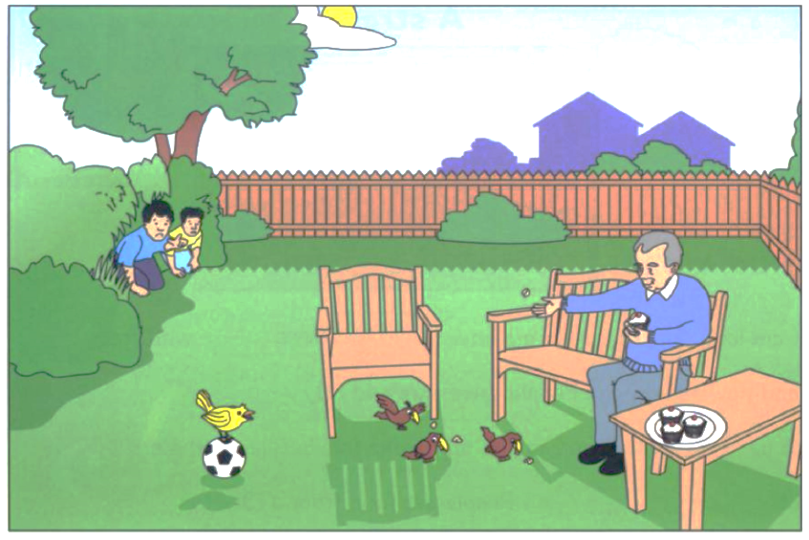

1. There are houses are behind the garden. ...................................

2. Grandpa is singing ...................................

3. There are two children. ...................................

4. A bird is flying in the sky. ...................................

5. The ball is on the table . ...................................

**3. Read, choose and write.**

|  |
| --- |
| monkeys eggs help carrots |

Lan and Tuan live at the farm. On the farm they grow (1) ............................., tomatoes, plums, figs, and potatoes. There are also animals: cows, hens, goats, and sheep. They get (2) ................................... from the hens and milk from the cows. They have two dogs and four cats on the farm. They (3) ................................... their family on the farm.

(4) Circle the best title.

A. The school trip

B. Life on the farm

C. The farmers

**4. Read and match the definition with the picture.**

|  |  |  |  |  |  |
| --- | --- | --- | --- | --- | --- |
|  |  |  | |  |  |
| a cow | a scarf | a band | | a fire station | a horse |
| 1. You can ride this animal. | | | ................................................... | | | |
| 2. The fire fighters work here. | | | ................................................... | | | |
| 3. It is big and we can get milk from it. | | | ................................................... | | | |
| 4. They usually play music at parties. | | | ................................................... | | | |
| 5. You can wear this around your neck. | | | ................................................... | | | |

**5. Read and fill in the blanks with the correct words.**

|  |  |  |  |  |  |
| --- | --- | --- | --- | --- | --- |
| Wednesday | lunchbox | three | breakfast | school | trees |
|  |  |  |  |  |  |

On (1) ......................................., there is a (2)...........................trip to a farm. There are sheep, cows, goats, and horses at the farm. There are also fruit (3)....................................: mangoes, oranges, and pears. Don’t be late for school. The bus leaves at nine o’clock. We go back to school at three o’clock. Bring your (4)............................................. and a drink. Wear your sun hats.

**6. Read the text and write Yes or No.**

Katie and Harry live at the Apple Farm. On the farm they grow vegetables: carrots, tomatoes, and potatoes. They have fruit trees, too: apples, plums and figs. There are also animals on the farm: hens, cows, goats and sheep.

They get eggs from the hens. They get milk from the cows. They get milk from the goats, too. There are also two dogs and four cats on the farm. Katie and Harry help their family on the farm.

1 Katie and Harry live at Pear Farm. .......................

2 There are many animals and trees on the farm. .......................

3 Katie and Harry help their friends on the farm. .......................

4 We get most of our food from the farms. .......................

**7. Write the words.**

|  |  |
| --- | --- |
|  |  |
| **1.** ................................... | **2.** ................................... |
|  |  |
| **3.** ................................... | **4.** ................................... |

**8. Complete the sentences.**

|  |  |
| --- | --- |
|  | 1**.** What’s she wearing?  She’s wearing a ................................... |
|  | 2. Rosy is ................................... than Billy. |

**9. Look at the letters. Write the words.**

|  |  |  |  |  |
| --- | --- | --- | --- | --- |
|  |  |  |  |  |
| o t g a | t i u e q | s e m s y | r i d b e | n o d y e k |
| 1. ………………… | 2. .......................... | 3. .......................... | 4. .......................... | 5. .......................... |

**10. Write some words to complete sentences about the picture.**

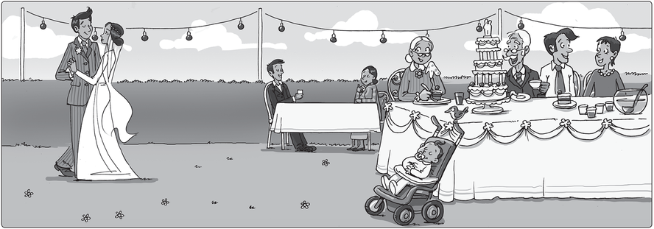

1. The baby is .................................................................

2. The bride is ................................................................

3. Grandma .......................................... talking.

**Từ vựng cần nhớ**

|  |  |  |  |
| --- | --- | --- | --- |
|  | ________________________ |  | ________________________ |
|  | ________________________ |  | ________________________ |
|  | ________________________ |  | ________________________ |
|  | ________________________ |  | ________________________ |
|  | ________________________ |  | ________________________ |
|  | ________________________ |  | ________________________ |
|  | ________________________ |  | ________________________ |
|  | ________________________ |  | ________________________ |
|  | ________________________ |  | ________________________ |
|  | ________________________ |  | ________________________ |
|  | ________________________ |  | ________________________ |